ARTIFICIAL INTELLIGENCE-CSA1717
SCENARIO BASED
SLOT-D
REGNO.192512417
1. Greedy Best-First Search
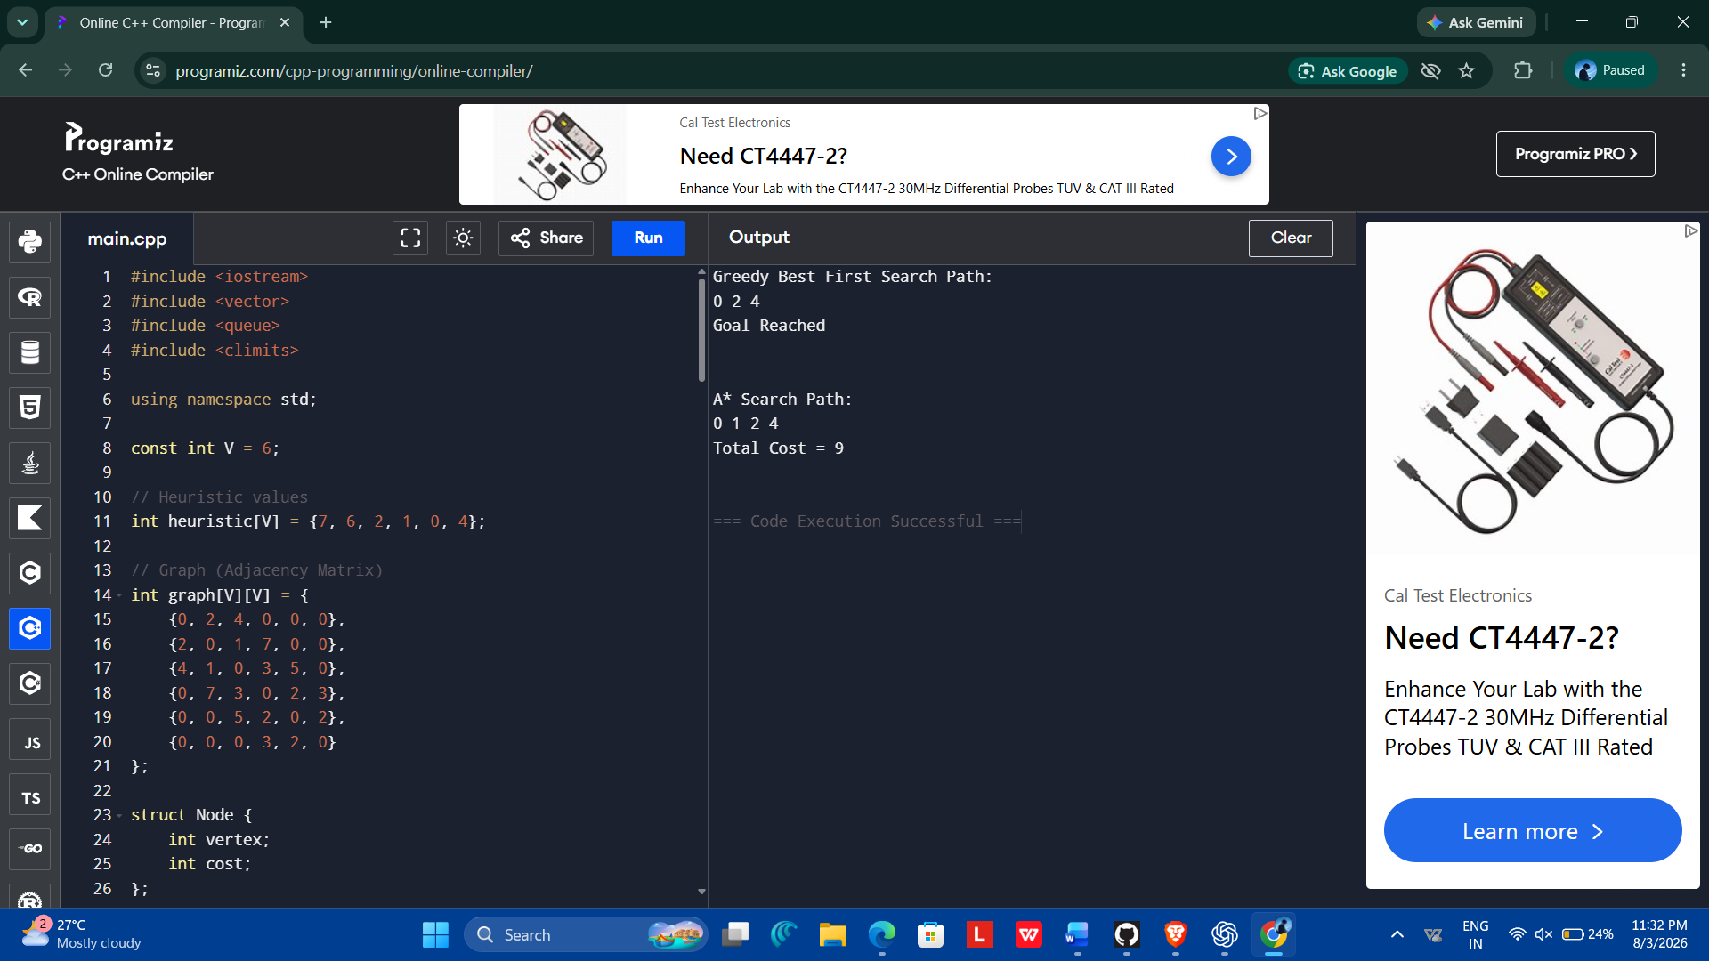
2. – Hill Climbing
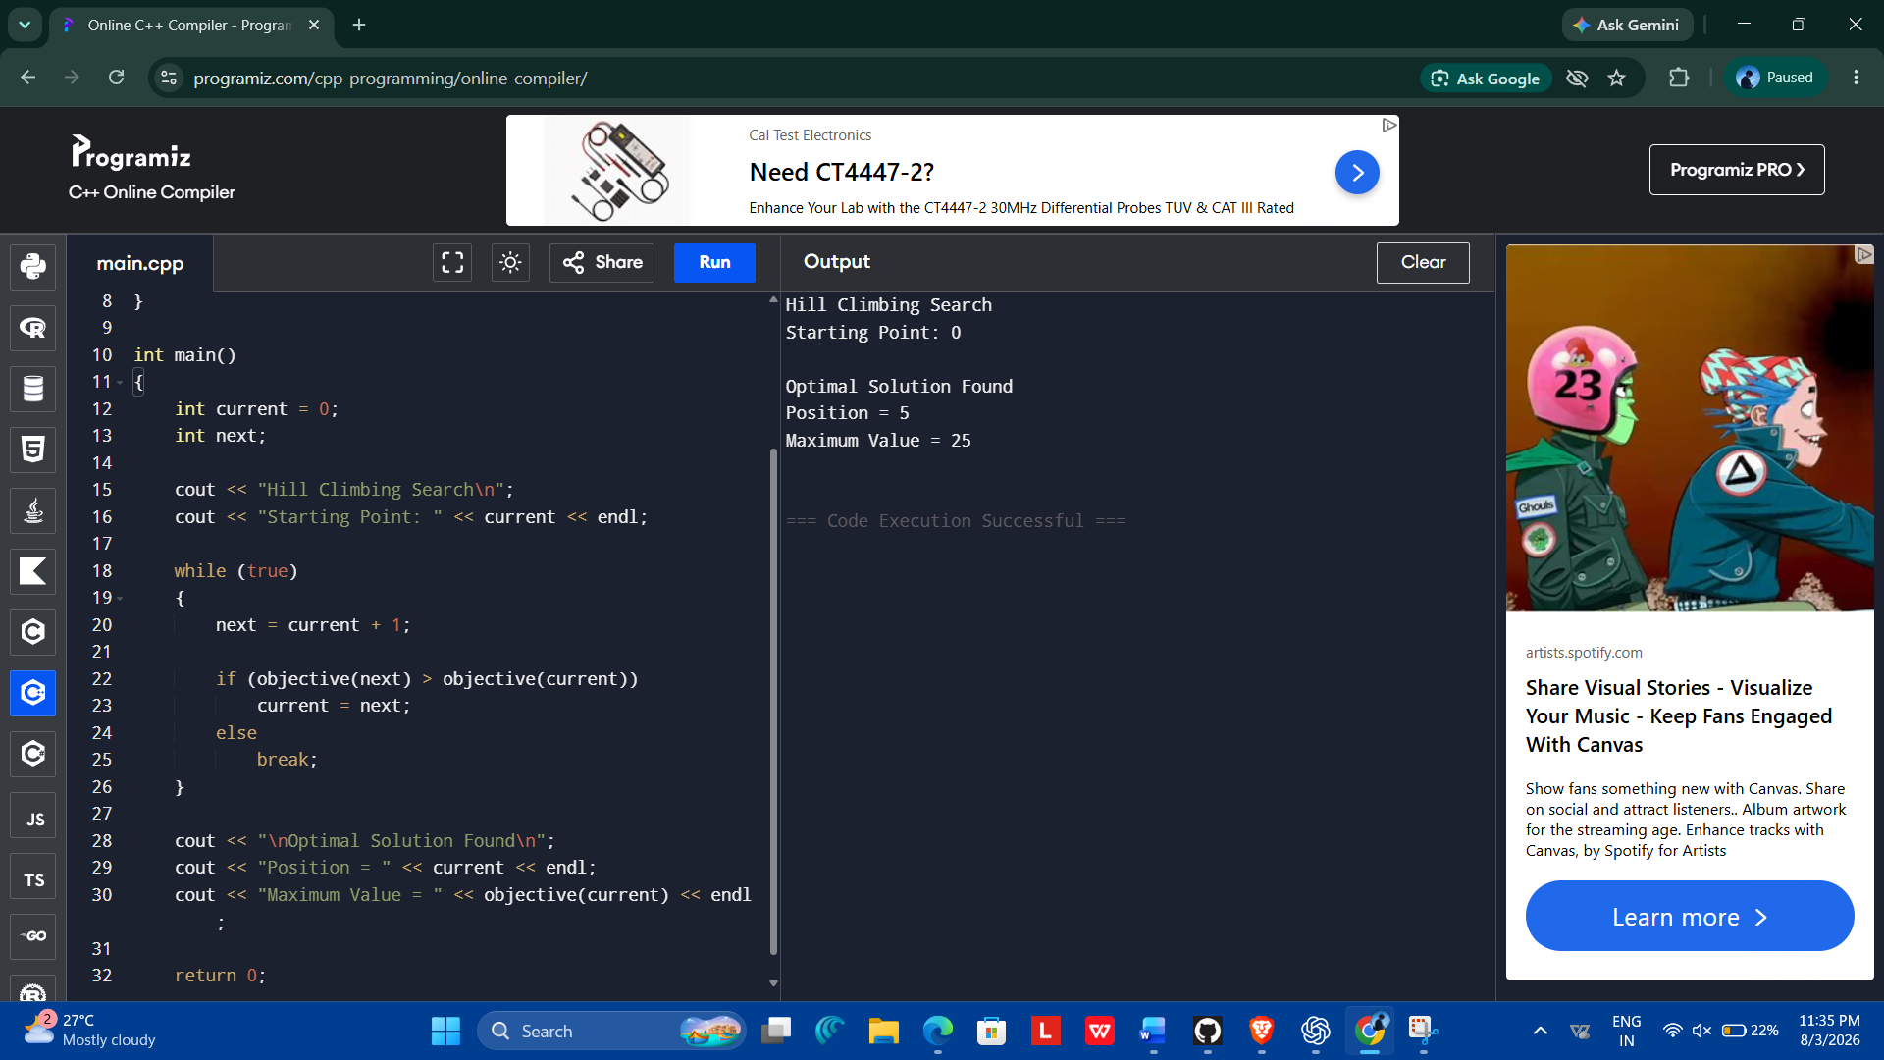

3. Online Search Agent
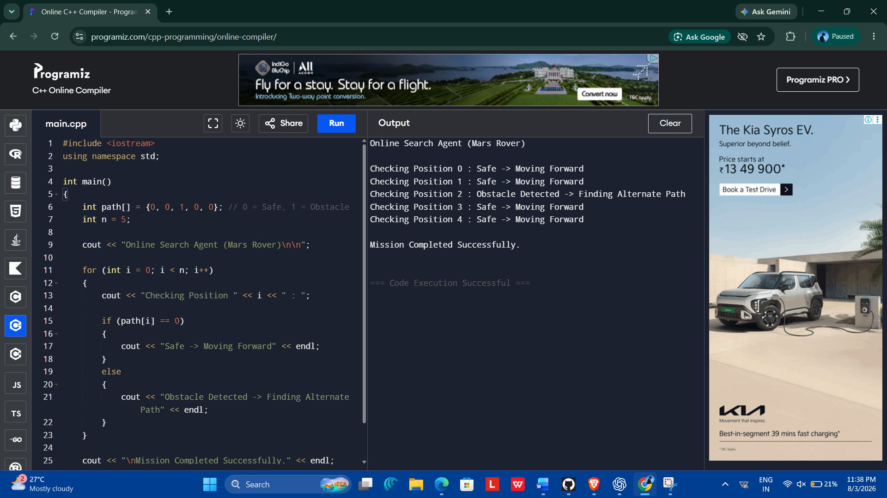
4. Constraint Satisfaction Problem (CSP)
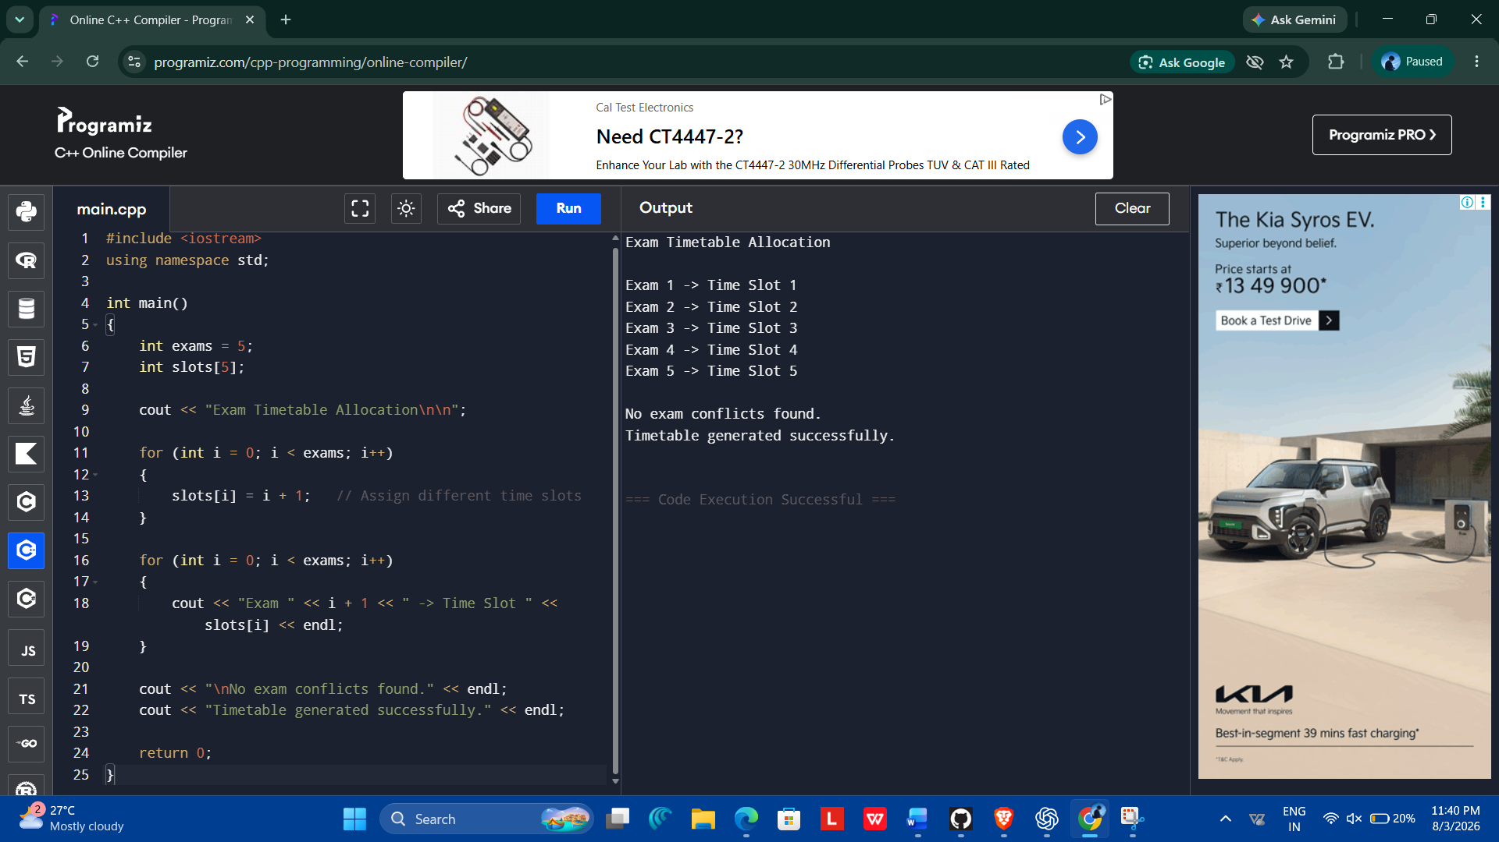

5. Minimax with Alpha-Beta Pruning

